Process Document of CRE Work Request
Submitted to:
Kirloskar Oil Engine Limited(KOEL)
Date: 29 May 2020

Submitted By:
Kloudq Technologies Limited
Plot No.1,Yena,Adwaitnagar,
Paud Phate,Erandawana,
Pune-411038,Maharashtra,INDIA

Document History:

Version | Author | Date | Comments
1.0 | Rohan Indalkar | 08/05/2020
2.0 | Rohan Indalkar | 29/05/2020

Table of Contents
1. Process flow: 4
2. New Work Request Document Creation Steps: 5
3. Work Request Process: 8
4. CRE Assembly Report Creation & Approval: 18
5. CRE Test Report Creation & Approval Process: 22
6. Teardown Report (First Observation & Final Dimensioning) Creation and Approval Process: 25
7. Merit rating process: 28

Process flow:

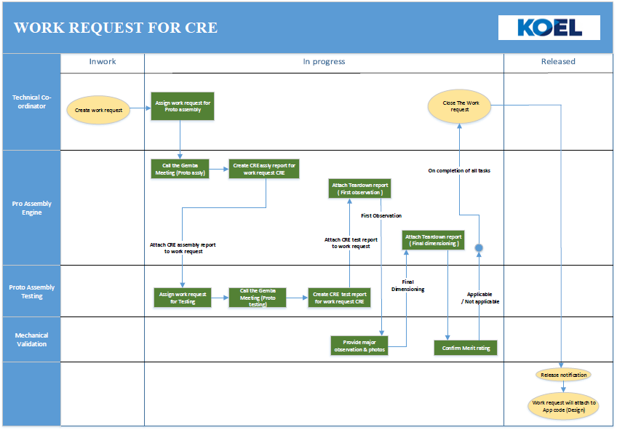

New Work Request Document Creation Steps:
- Go to browse tab then go to Libraries the go to Work Request library and then in the Folders.
Click Browse Tab Libraries Work Request Folders

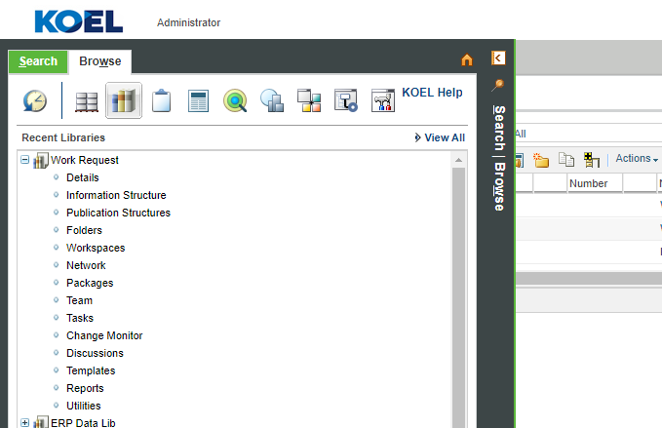

- In folders go to Work Request CRE folder.
Folders Work Request CRE
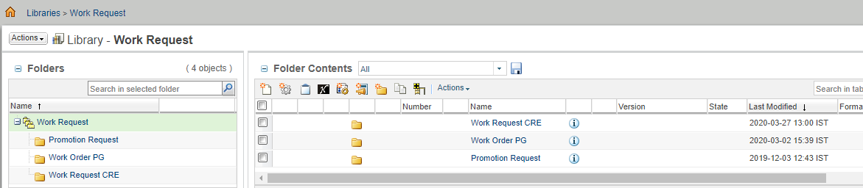

- Now click on New Document to create new Work Request document.

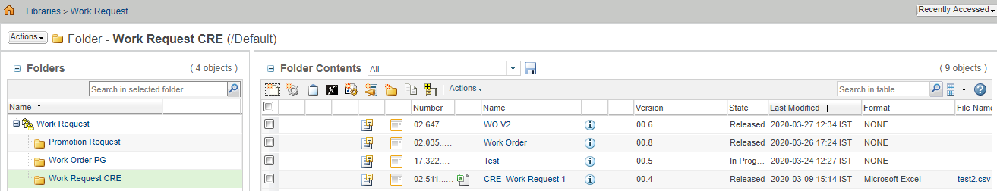

- Then click on the select type and select type as CRE Work Request.
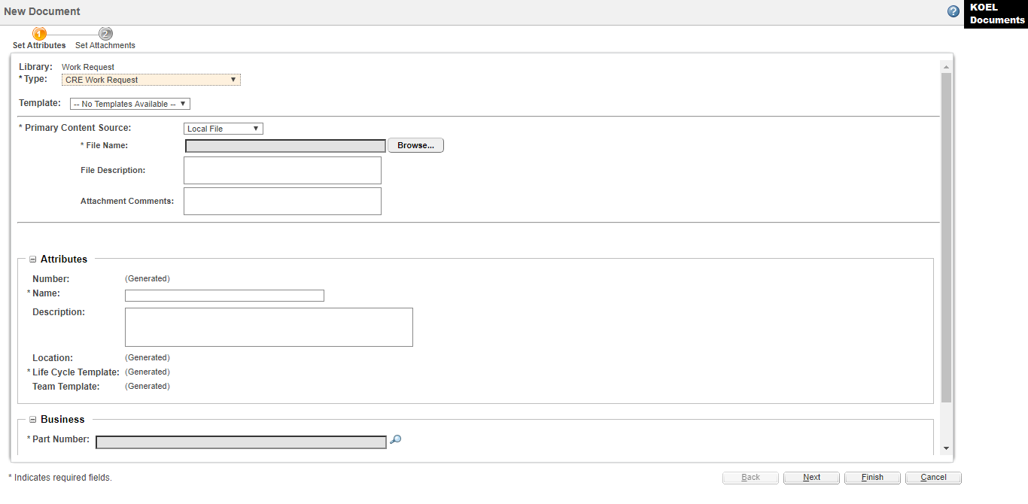

- Attach source file to Work Request through browse button


- Fill the mandatory details and click on Next button.
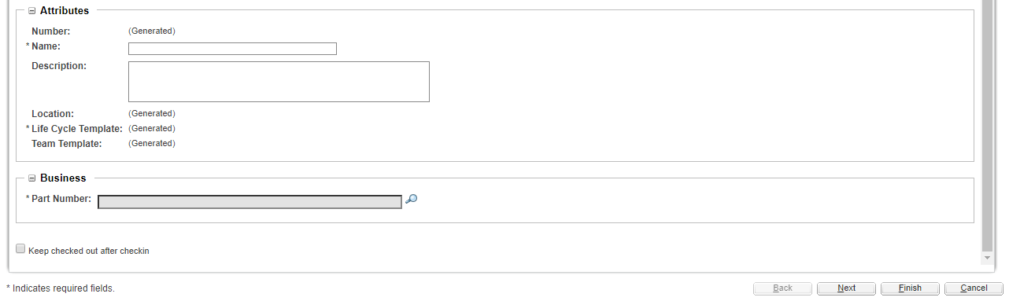

- Click on search icon to select part no. below window appears. Enter valid details to search part no. & select Design view of the required part.
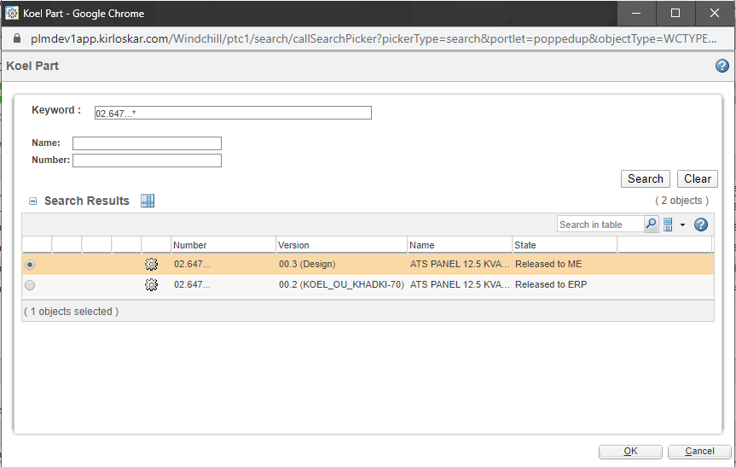

- Attach if there are any extra attachments then click on the finish button.

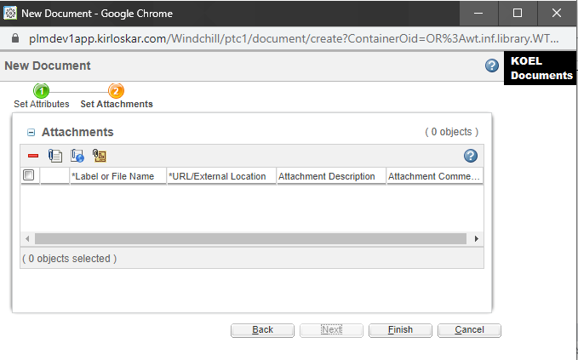

Work Request Process:
- Once document is created successfully it appears as follows.
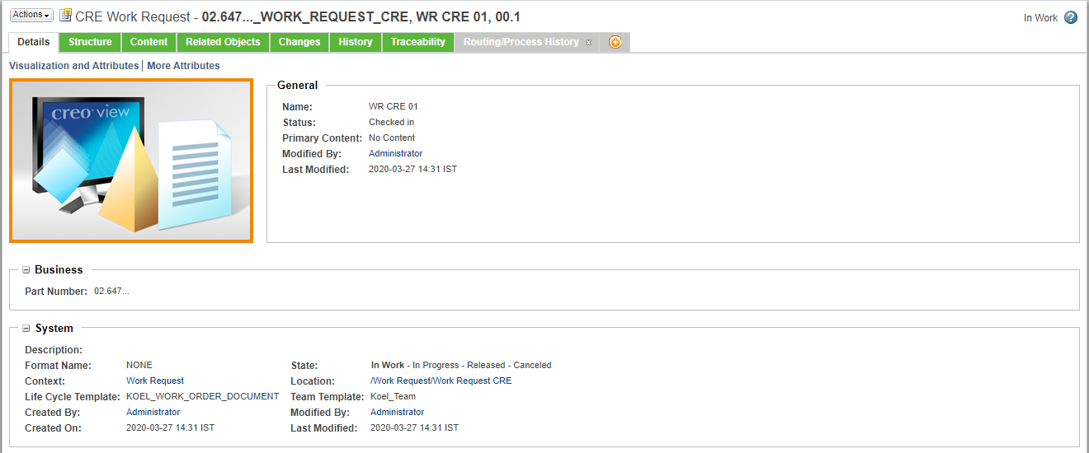

- Select Routing/Process History tab for viewing / completion of tasks.
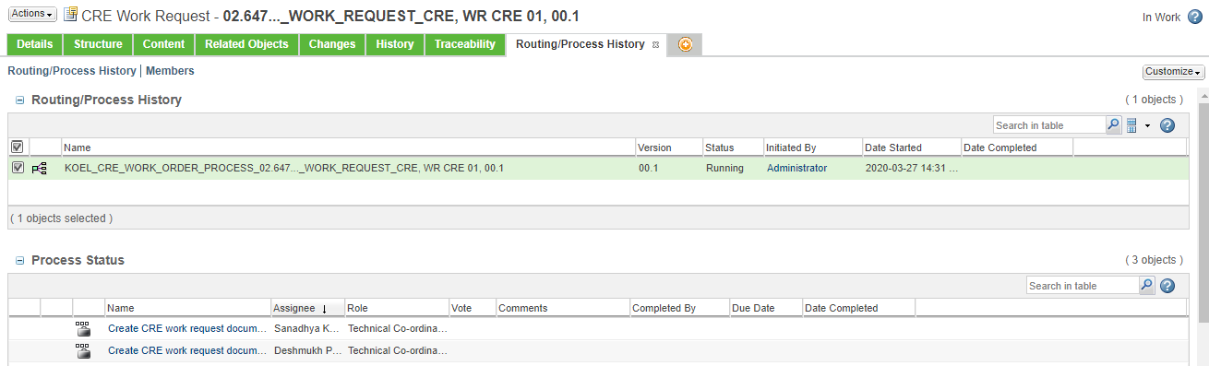
- First task is to Create CRE work request document which is assigned to Technical Co-ordinator. As per the given instructions on task page user completes the task.
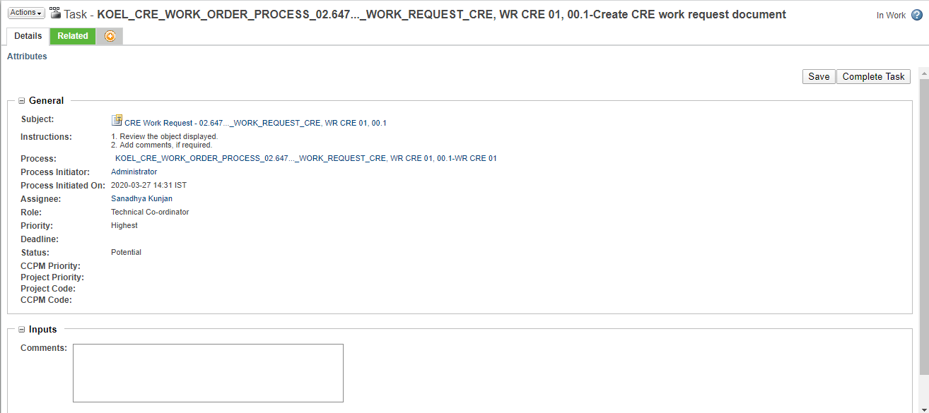
- Next task is again of Technical Co-ordinator to Assign work request for assembly.
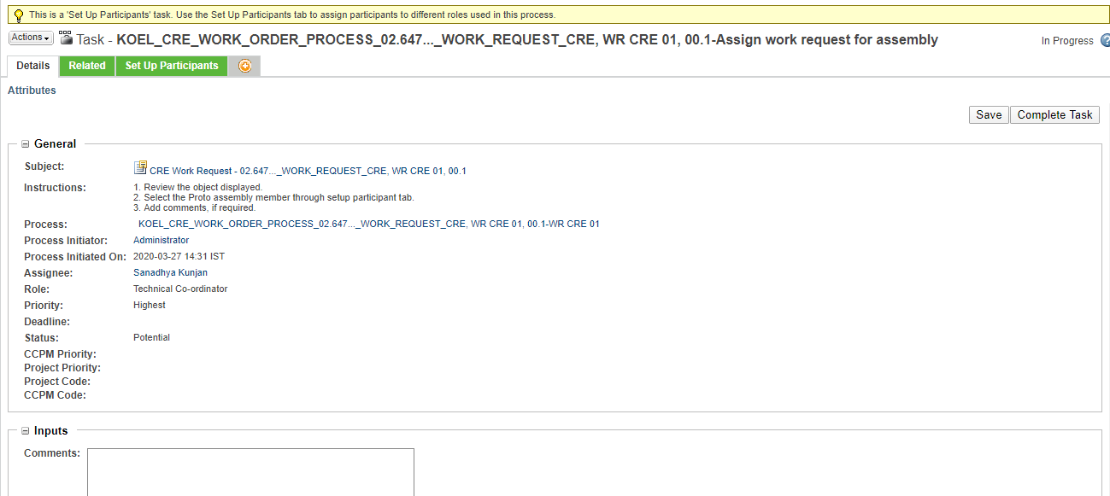
  - User has to select a participant from Proto Assembly department for further process as shown below.
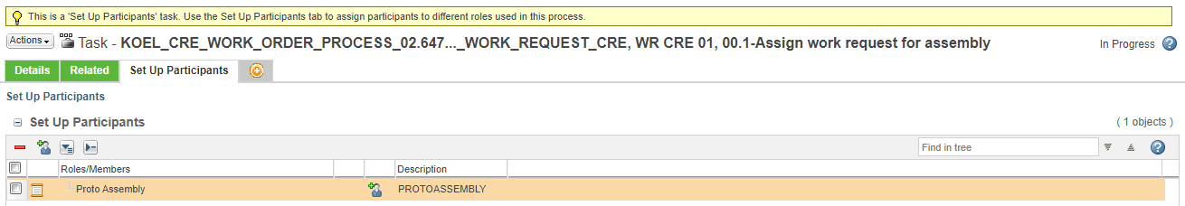
  - After selecting Add participant button shown above below tab appears in which a participant from Proto Assembly department can be selected as follows.
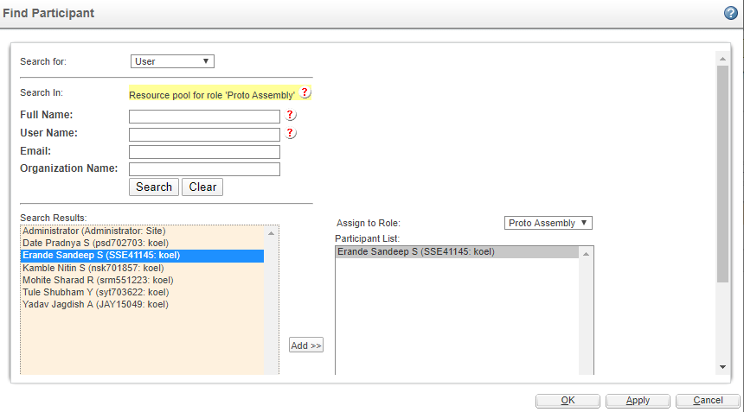

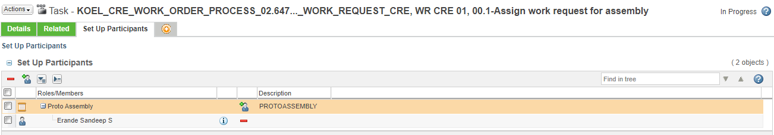



- Next task Call Gemba meeting (Proto Assembly) is assigned to Proto Assembly participant in which user has to add Gemba points in comments section & complete the task.
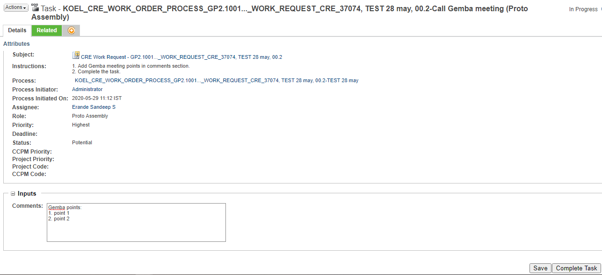

- Next task Create CRE assembly report for CRE work request is assigned to Proto Assembly participant in which user has to create assembly report & get it approved if possible before task completion.
  - Select the link in instruction to create Assembly report.
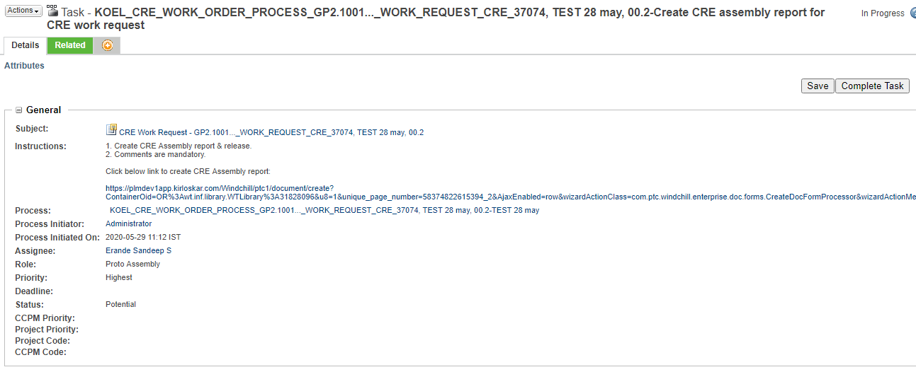
  - After creation of assembly report it has to be individually approved through another approval process set on the document & after approval it gets automatically attached to Work request.
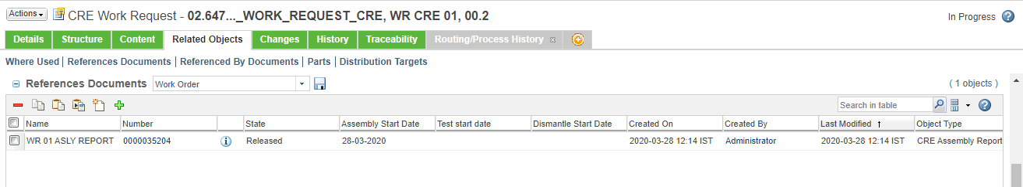

- On completion of above task Proto Testing head is assigned with Assign work request for testing task.
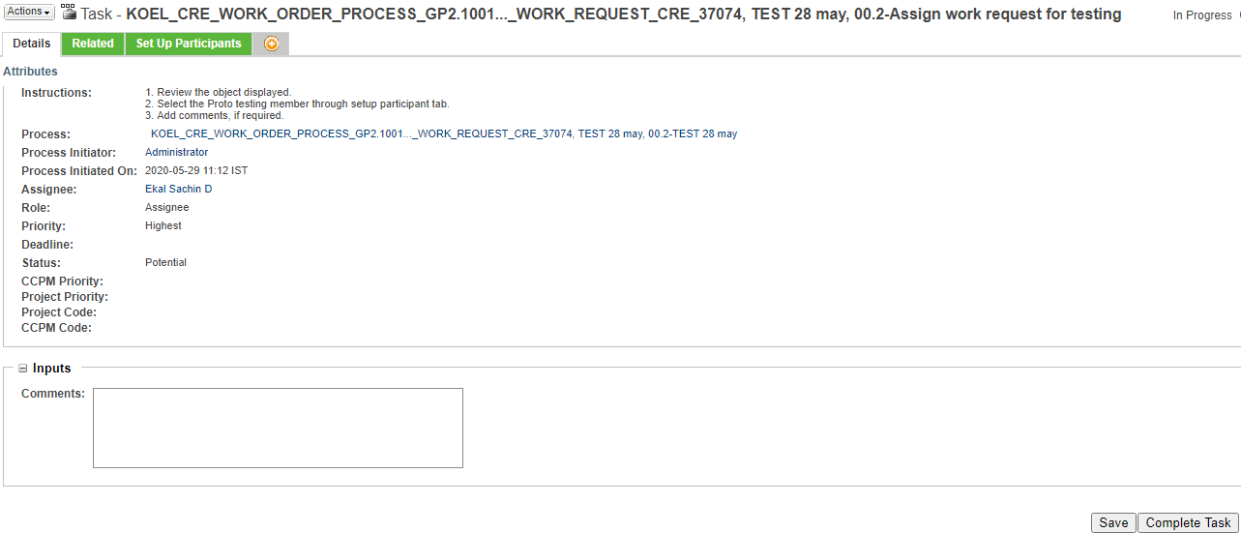

  - User has to select a participant from Proto Testing department for further process as shown below.
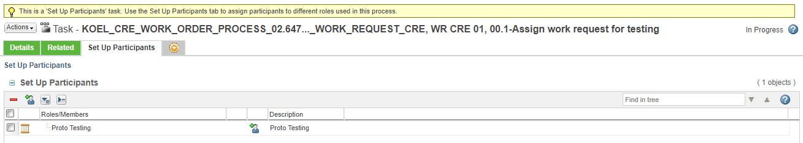
  - After selecting Add participant button shown above below tab appears in which a participant from Proto Testing department can be selected as follows.
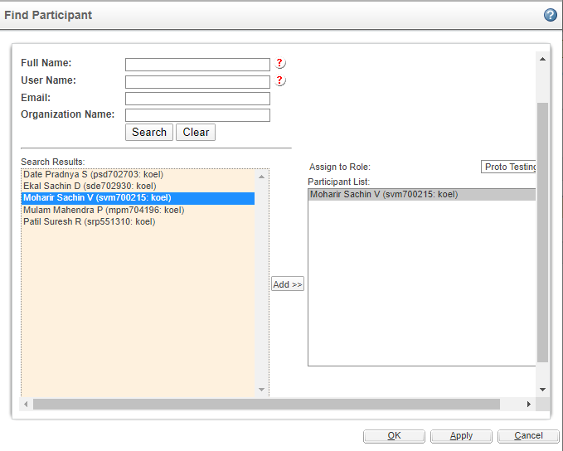

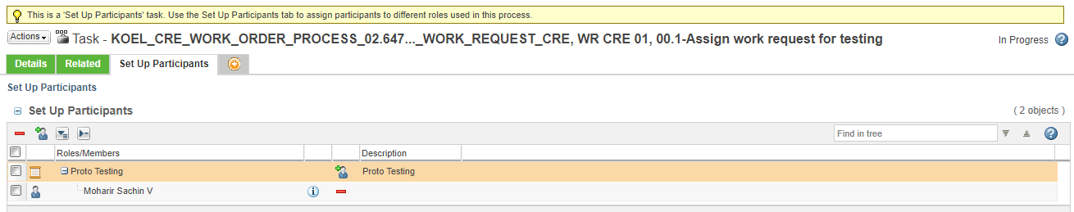

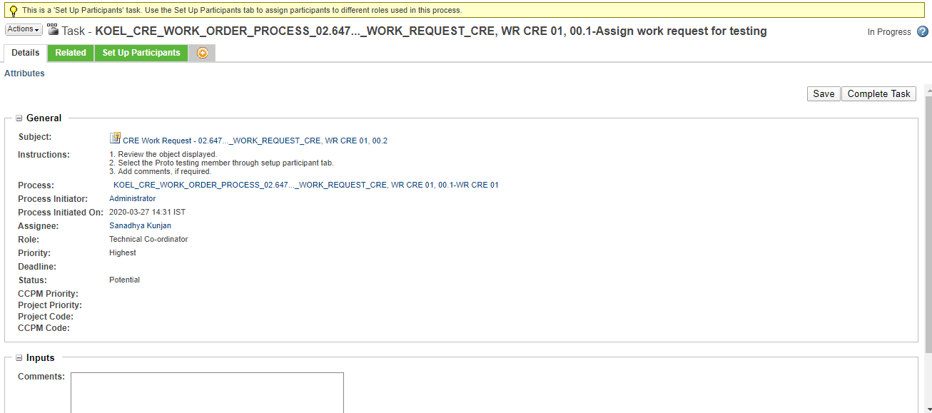

- Next task Call Gemba meeting (Proto Testing) is assigned to Proto Testing participant in which user has to add Gemba points in comments section & complete the task.
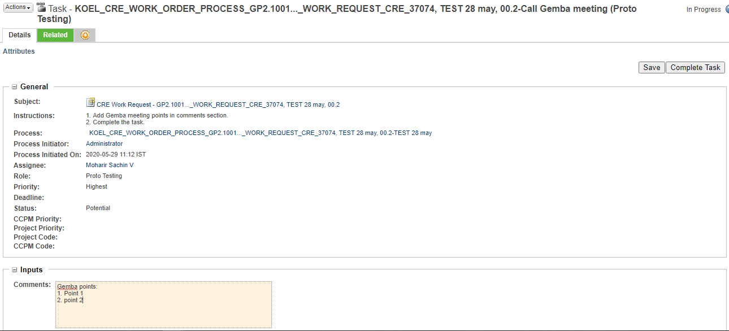
- Next task Create CRE Test report is assigned to Proto Testing participant in which user has to create testing report & get it approved if possible before task completion.
  - Select the link in instruction to create Testing report.
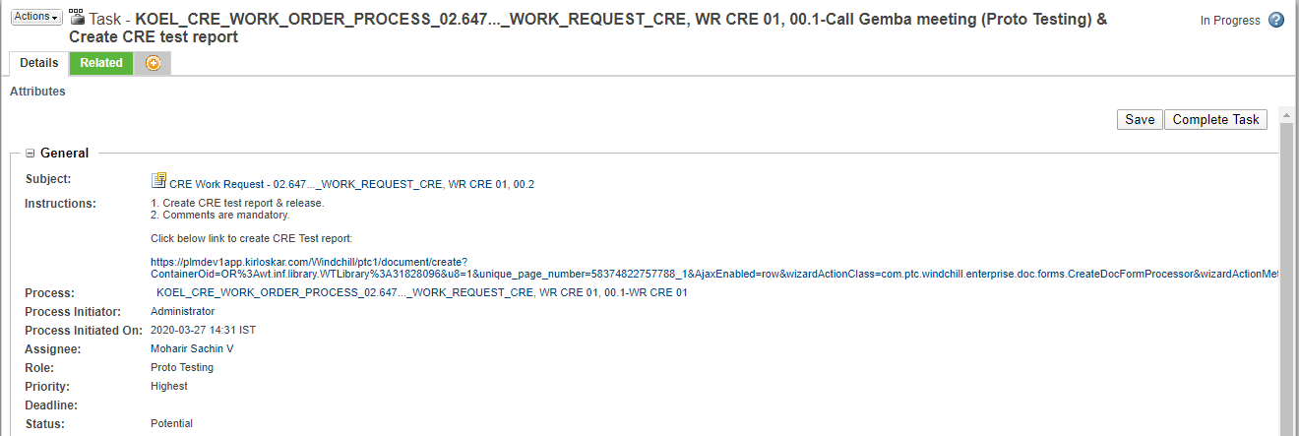
  - After creation of testing report it has to be individually approved through another approval process set on the document & after approval it gets automatically attached to Work request.
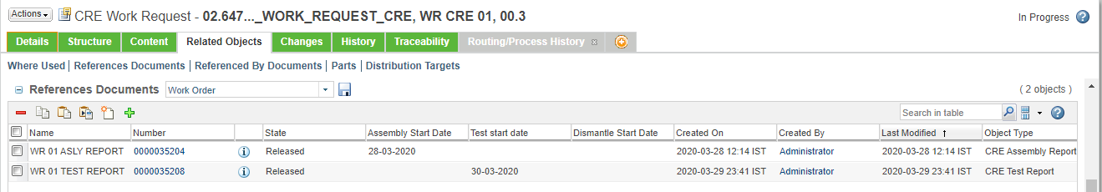

- Next task Create CRE Teardown report (First Observation) is assigned to previous selected Proto Assembly user.
  - Select the link in instruction to create Dismantle report (First Observation).
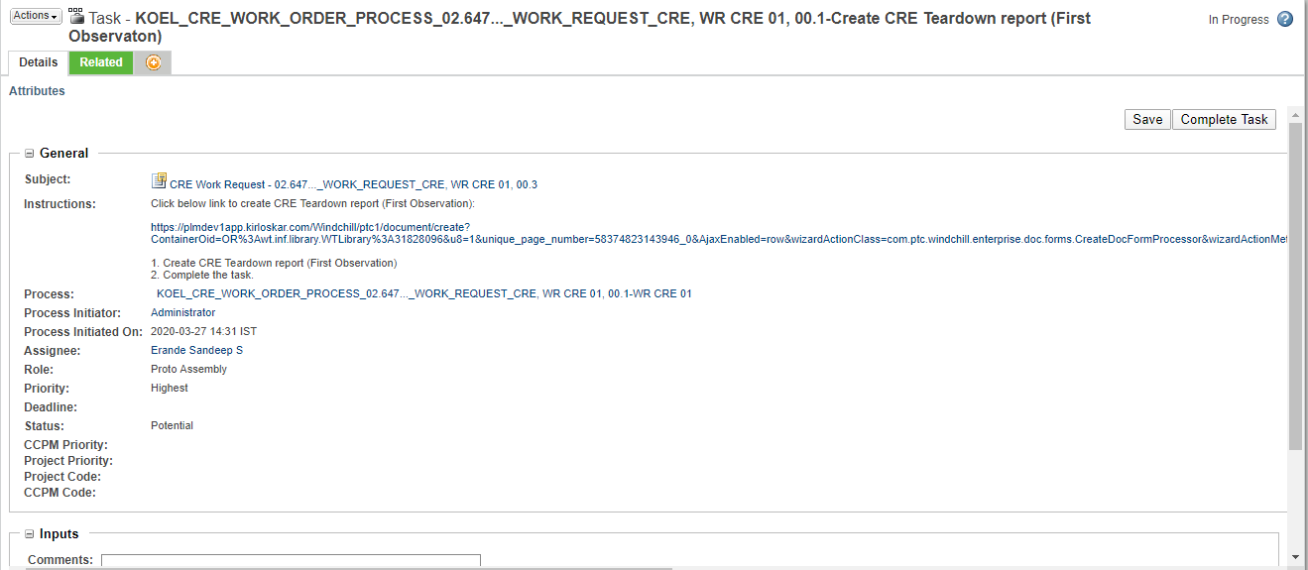
  - After creation of testing report it has to be individually approved through its approval process set on the document & after approval it gets automatically attached to Work request.
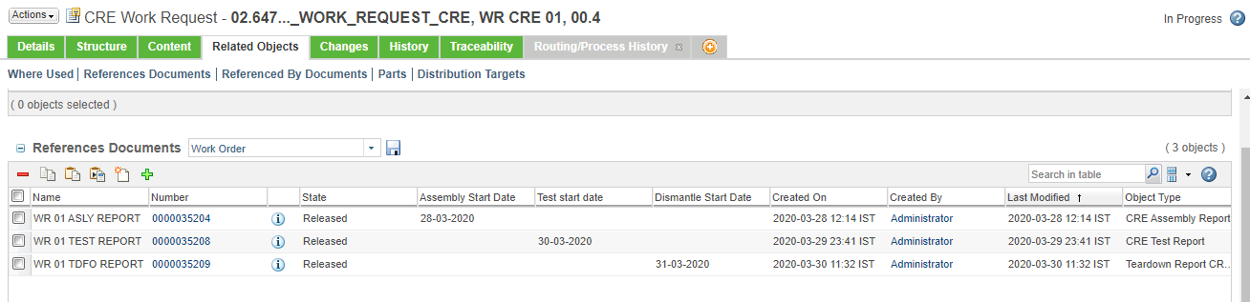

- Next task Provide major observations & photos is assigned to Mechanical validation team.
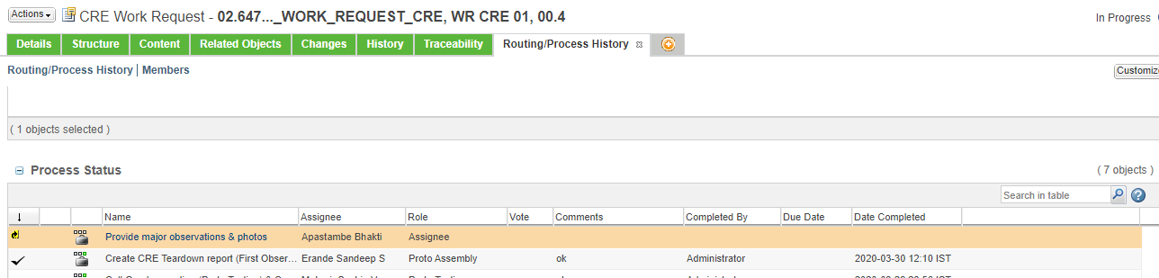
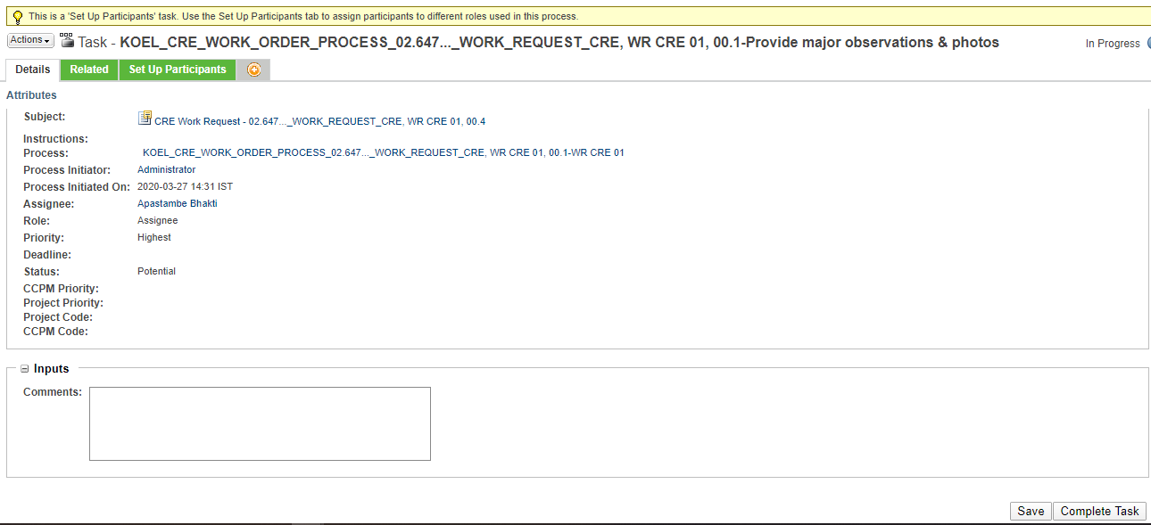

- Next task Create CRE Teardown report (Final dimensioning) is again assigned to Proto assembly participant in this process. User has to follow similar steps as that of CRE Teardown report (First Observation) & complete the task.
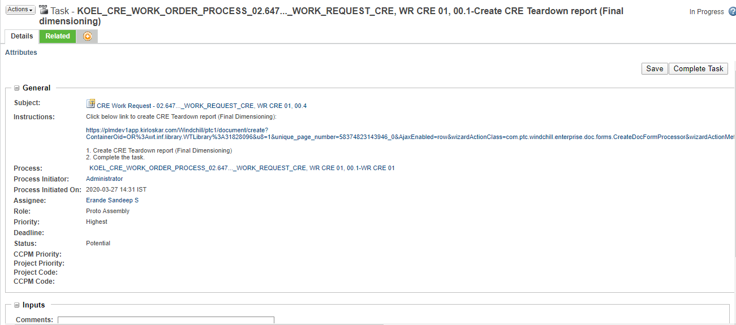

- After completion of above task, Confirm Merit rating task is assigned to Mechanical validation team.
  - If applicable user has to select the link & create Merit rating document by selecting the link given in task.

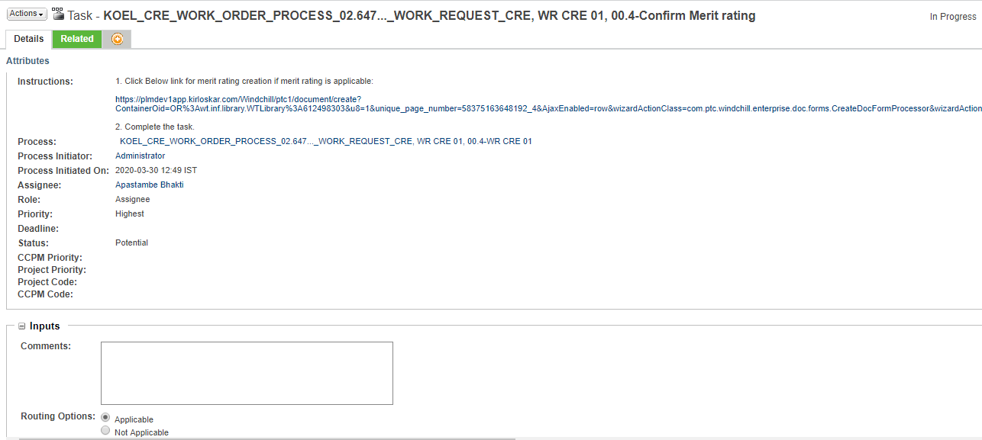
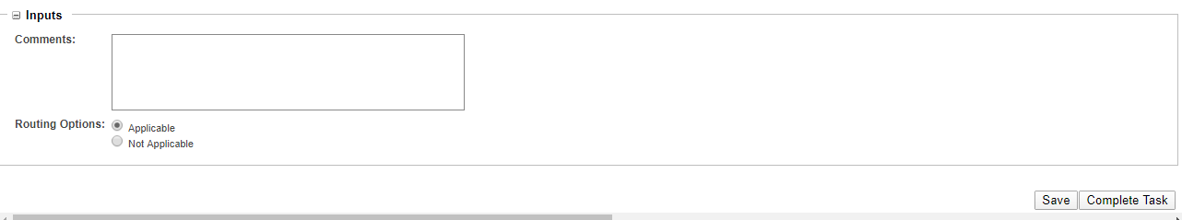
  - On completion of above task merit rating is attach to Work Request.
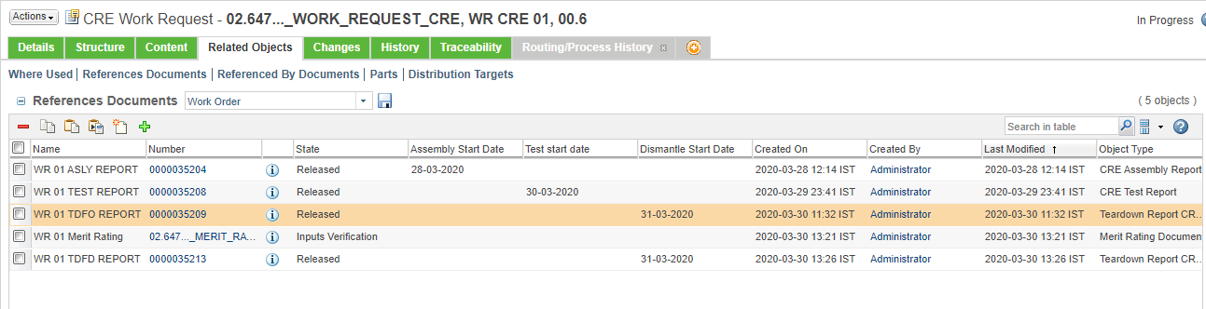

- Next task Close work order is assigned to Technical Co-ordinator.

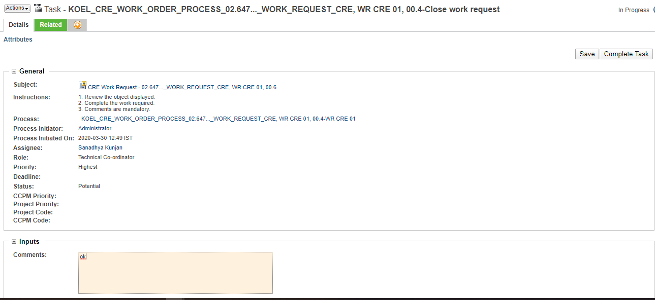

- On completion of all task Work Request state changes to Released & it gets attached to related App code / Part no.

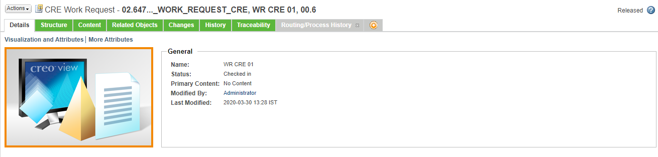

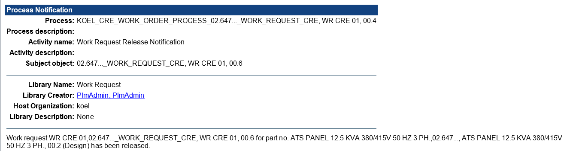

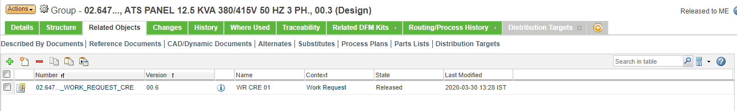

CRE Assembly Report Creation & Approval:
- Report can be created by going to browse tab then go to Libraries the go to CRE Reports library and then in the Folders or through the link given on task page.
Click Browse Tab Libraries CRE Reports Folders

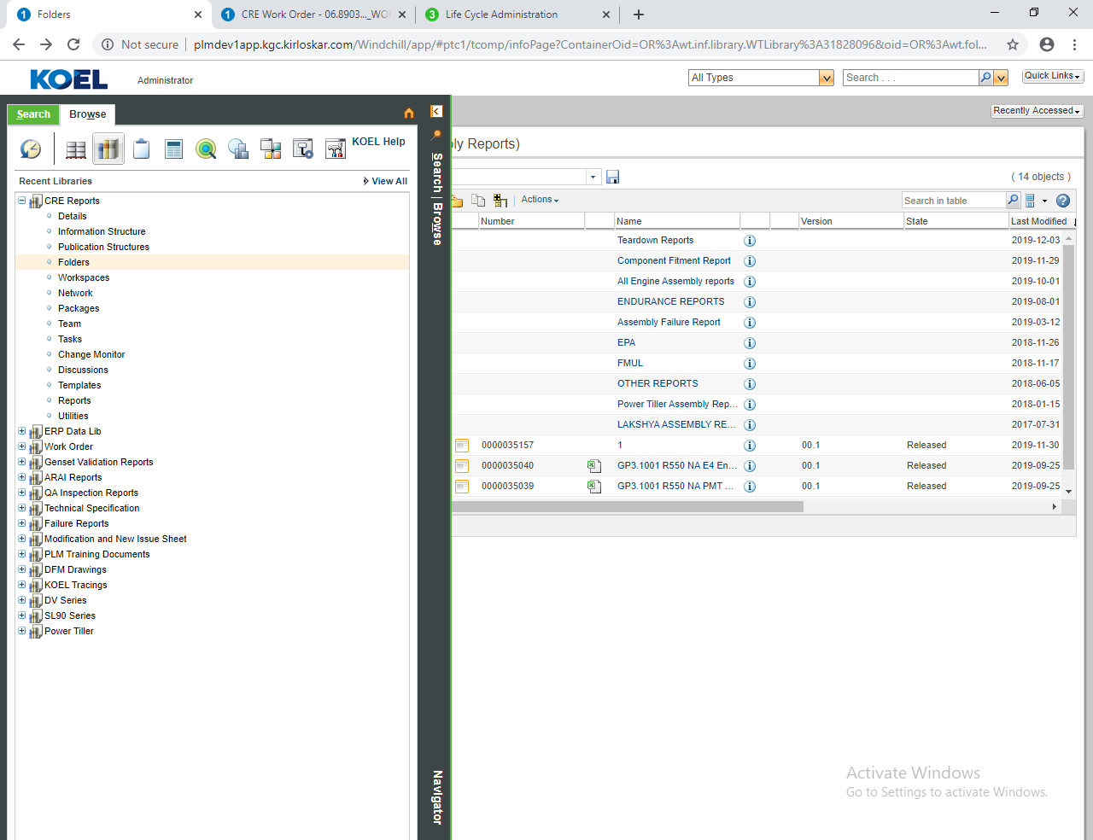

- In folders go to CRE Assembly Reports folder
Folders CRE Assembly Reports
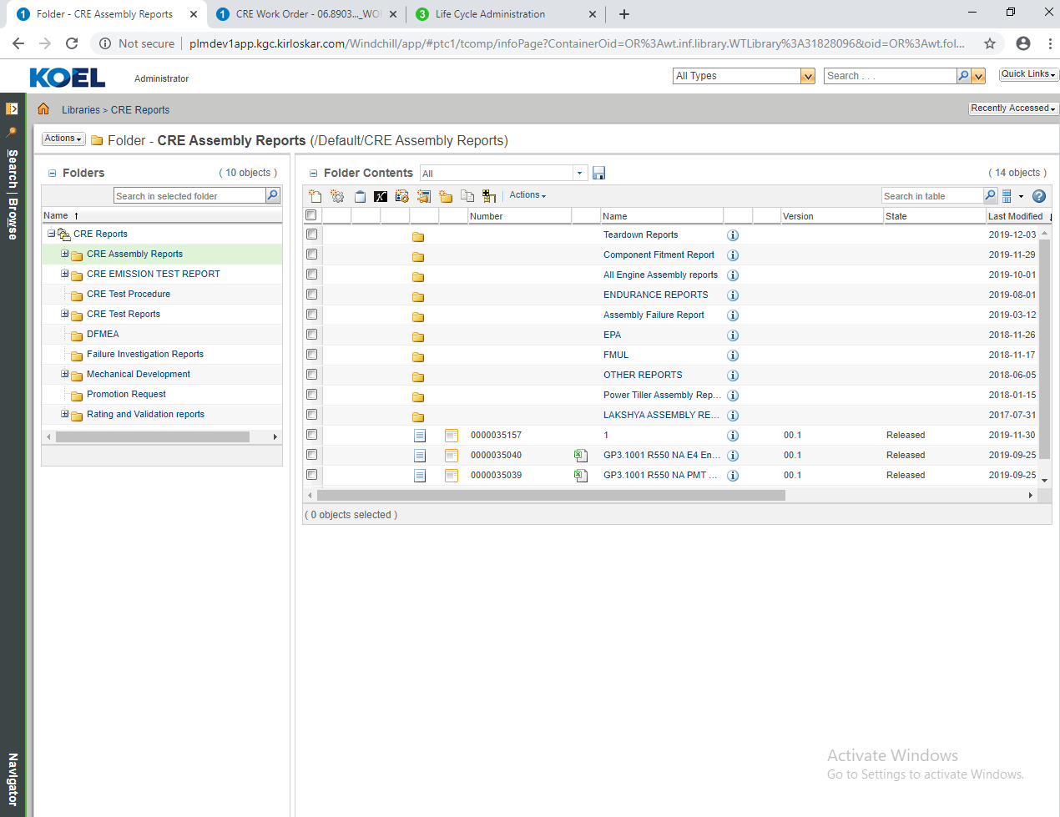

- Now click on the new document to create new CRE Assembly report.


- Select type CRE Assembly Report from select type.
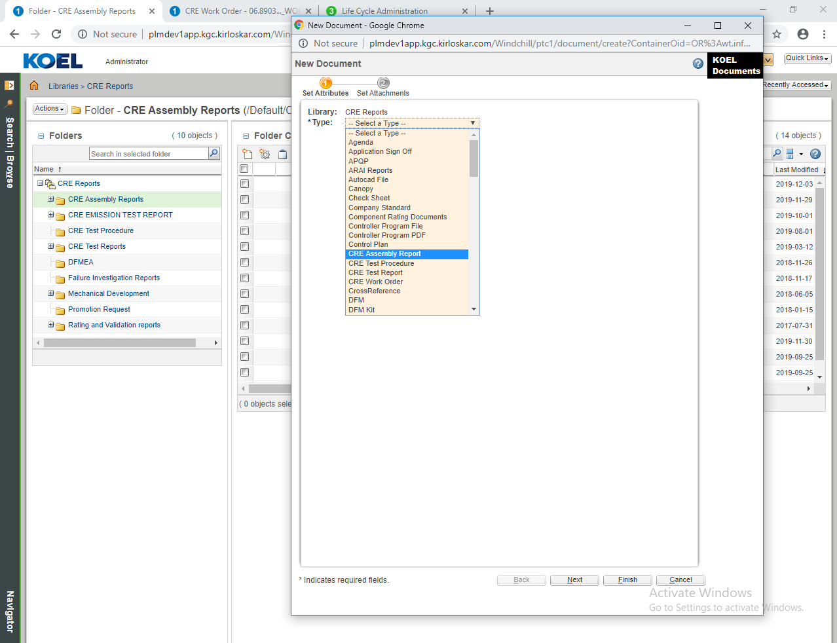

- Attach source file to CRE assembly report through browse button.
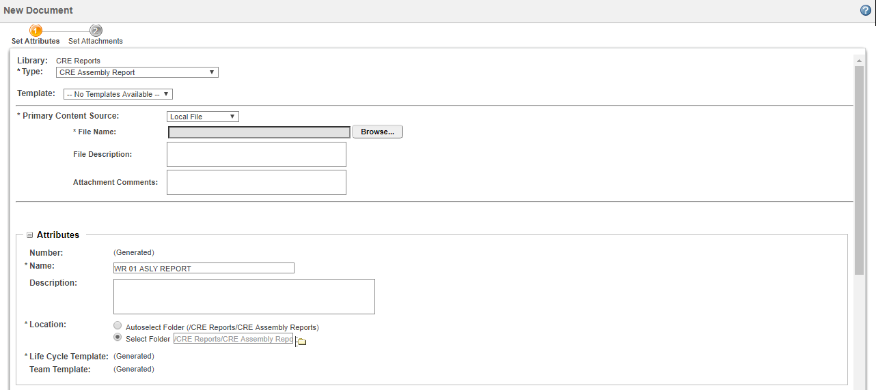

- Fill all the mandatory fields and click on finish.
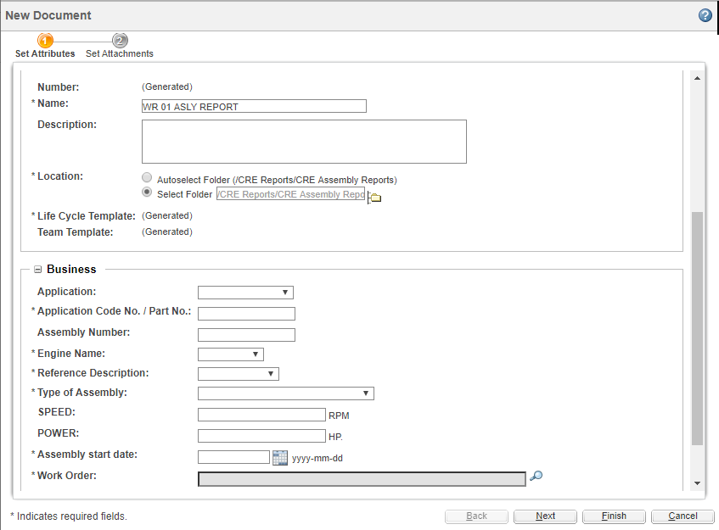

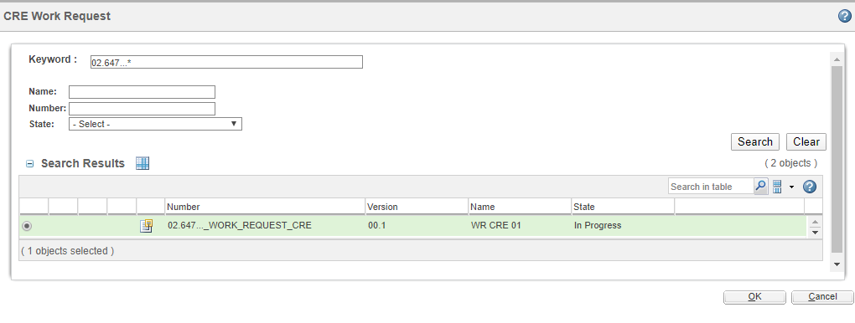

- On creation of the document approval task is assigned to CRE Assembly Report Reviewer. Approver can Approve / Rework document for changes.
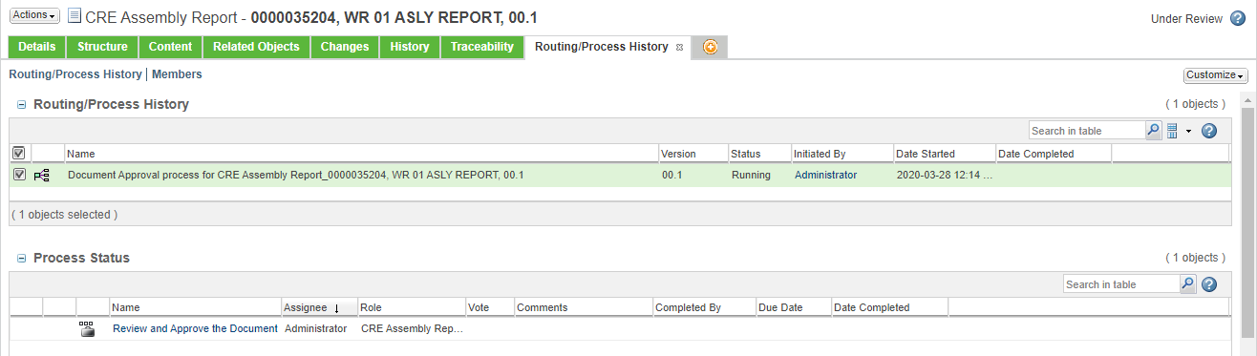
- On approval document state changes & it gets attached to respective Work Request.
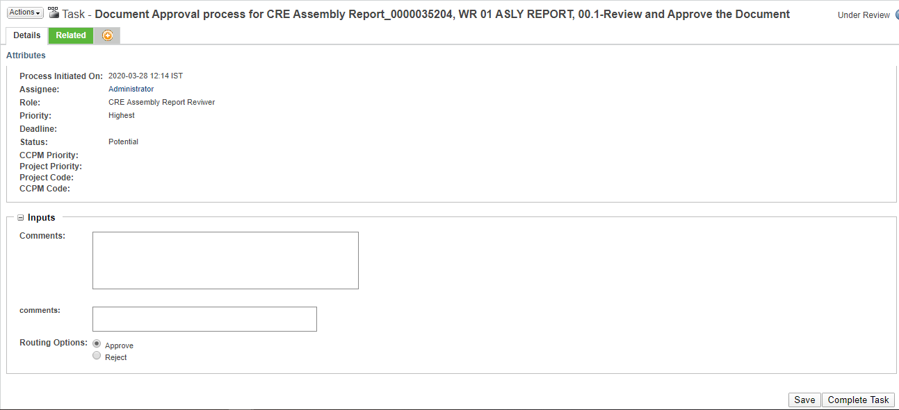

CRE Test Report Creation & Approval Process:
- Report can be created by going to browse tab then go to Libraries the go to CRE Reports library and then in the Folders or through the link given on task page.
Click Browse Tab Libraries CRE Reports Folders



- In folders go to CRE Test Reports folder
Folders CRE Test Reports
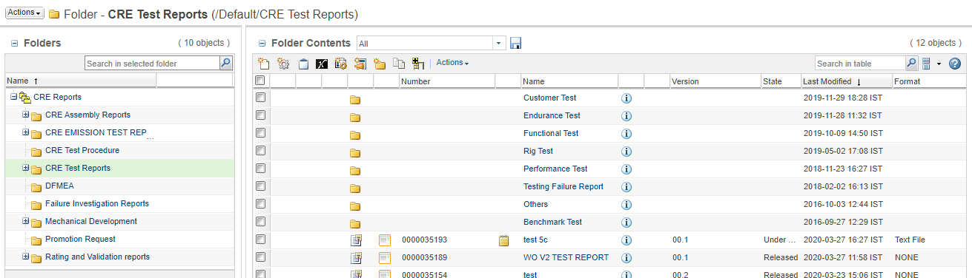

- Now click on the new document to create new CRE Test report.


- Select type CRE Test Report from select type.
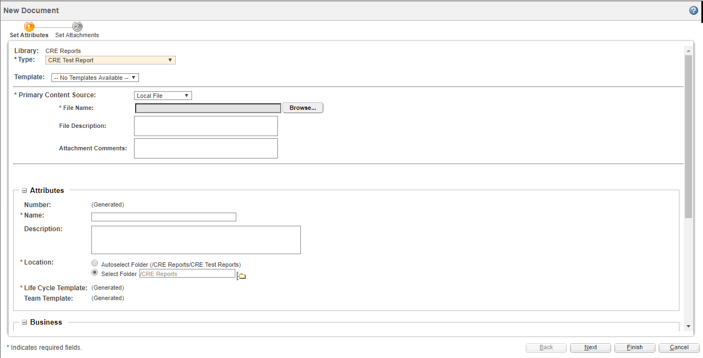
- Attach source file to CRE assembly report through browse button.


- Fill all the mandatory fields and click on finish.
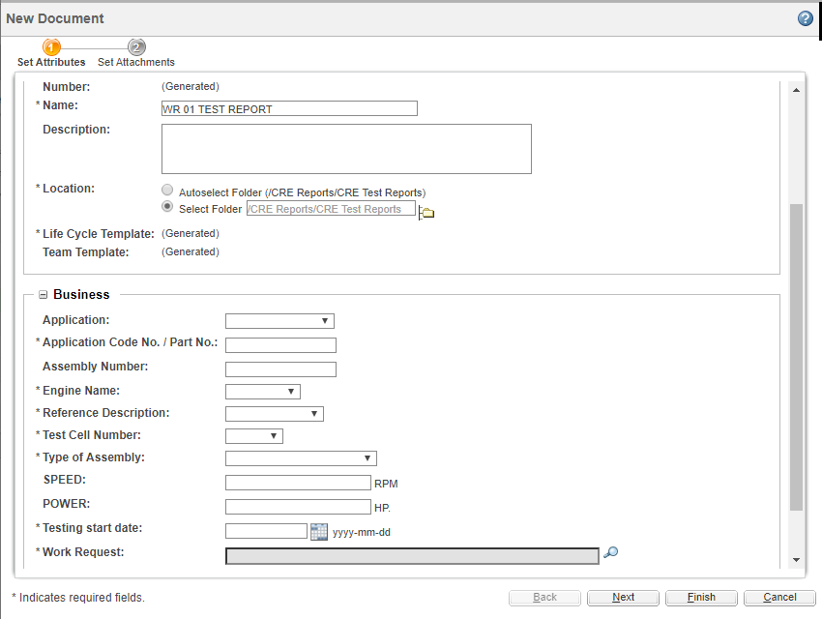



- On creation of the document approval task is assigned to CRE Report Approver. Approver can Approve / Rework document for changes.
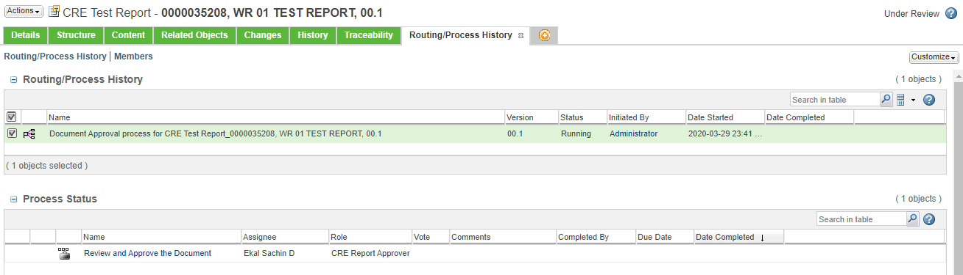
- On approval document state changes & it gets attached to respective Work Request.
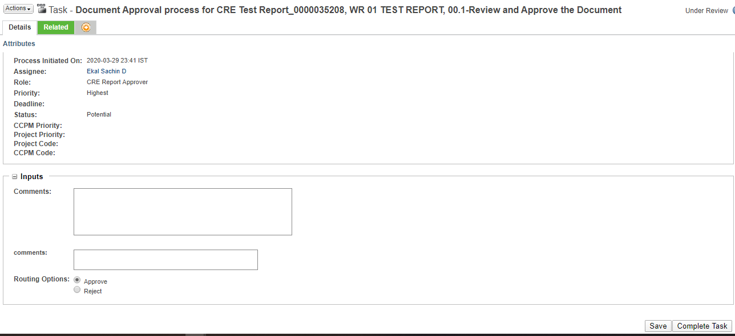

Teardown Report (First Observation & Final Dimensioning) Creation and Approval Process:

- Go to browse tab then go to Libraries the go to CRE Reports library and then in the Folders.
Click Browse Tab Libraries CRE Reports Folders



- In folders go to CRE Assembly Reports folder then go to Teardown Reports
Folders CRE Assembly Reports Teardown Reports New Document

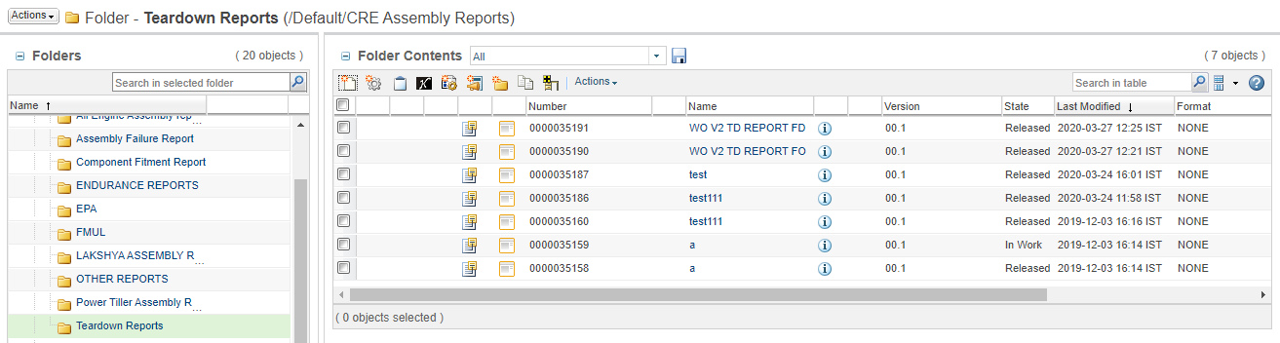

- Select Teardown Report from select type & attach source file to Teardown report through browse button.

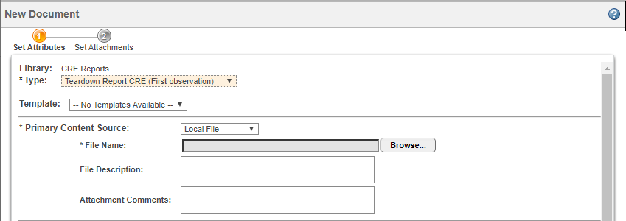

- Fill all the mandatory fields and click finish.
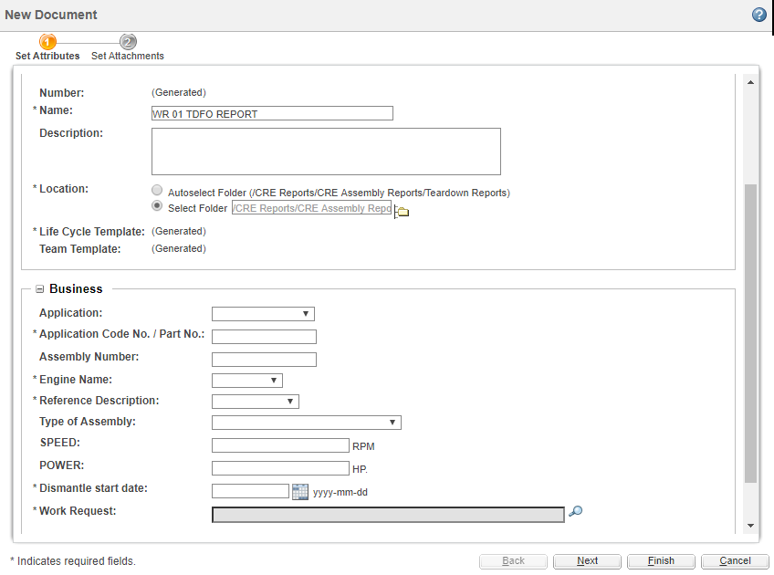



- On creation of the document approval task is assigned to CRE Assembly Report Reviewer. Approver can Approve / Rework document for changes.
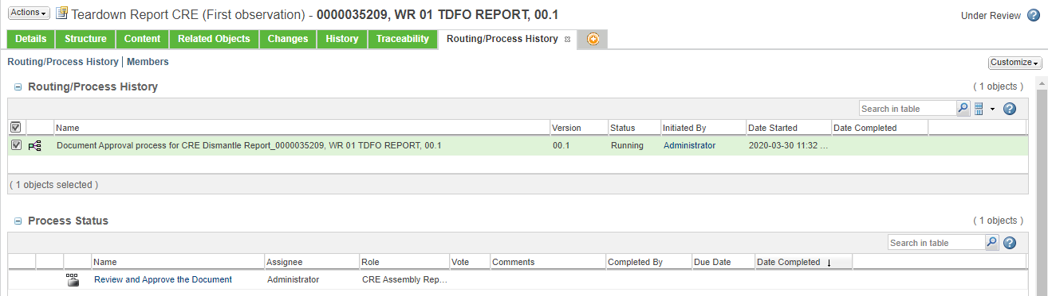
- On approval document state changes & it gets attached to respective Work Request.
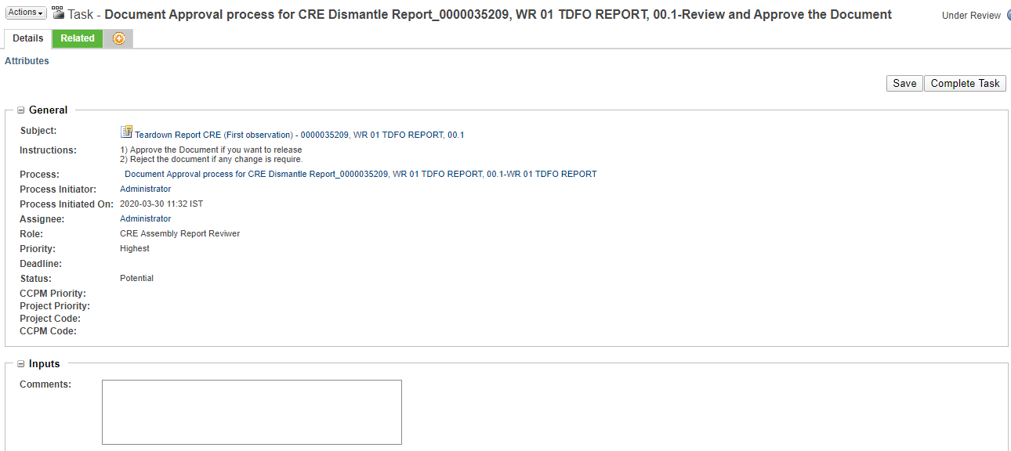

Note: Teardown Report (Final Dimensioning) creation is similar to Teardown Report (First Observation) only document type selection is different while approval process is same.

Merit rating process:

- On selecting link on task page below page of document creation appears. Select type as Merit rating document & attach source file as shown below.

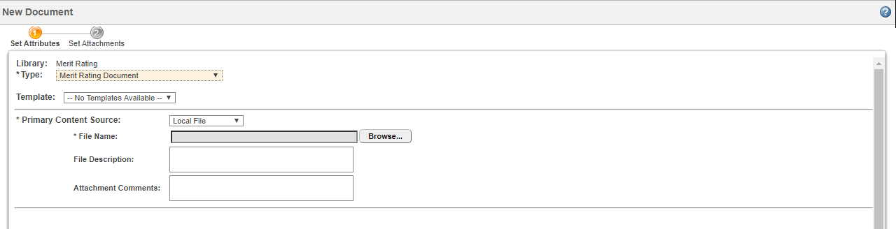

- Fill in the mandatory details & select finish.
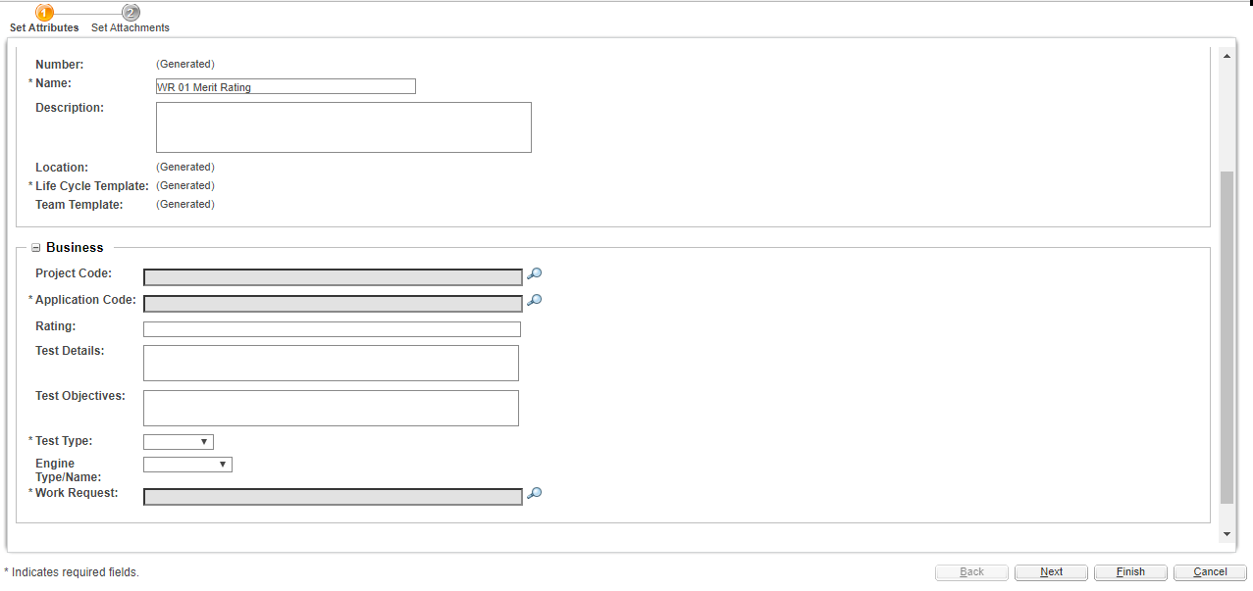

- Refer below document for merit rating process details.

